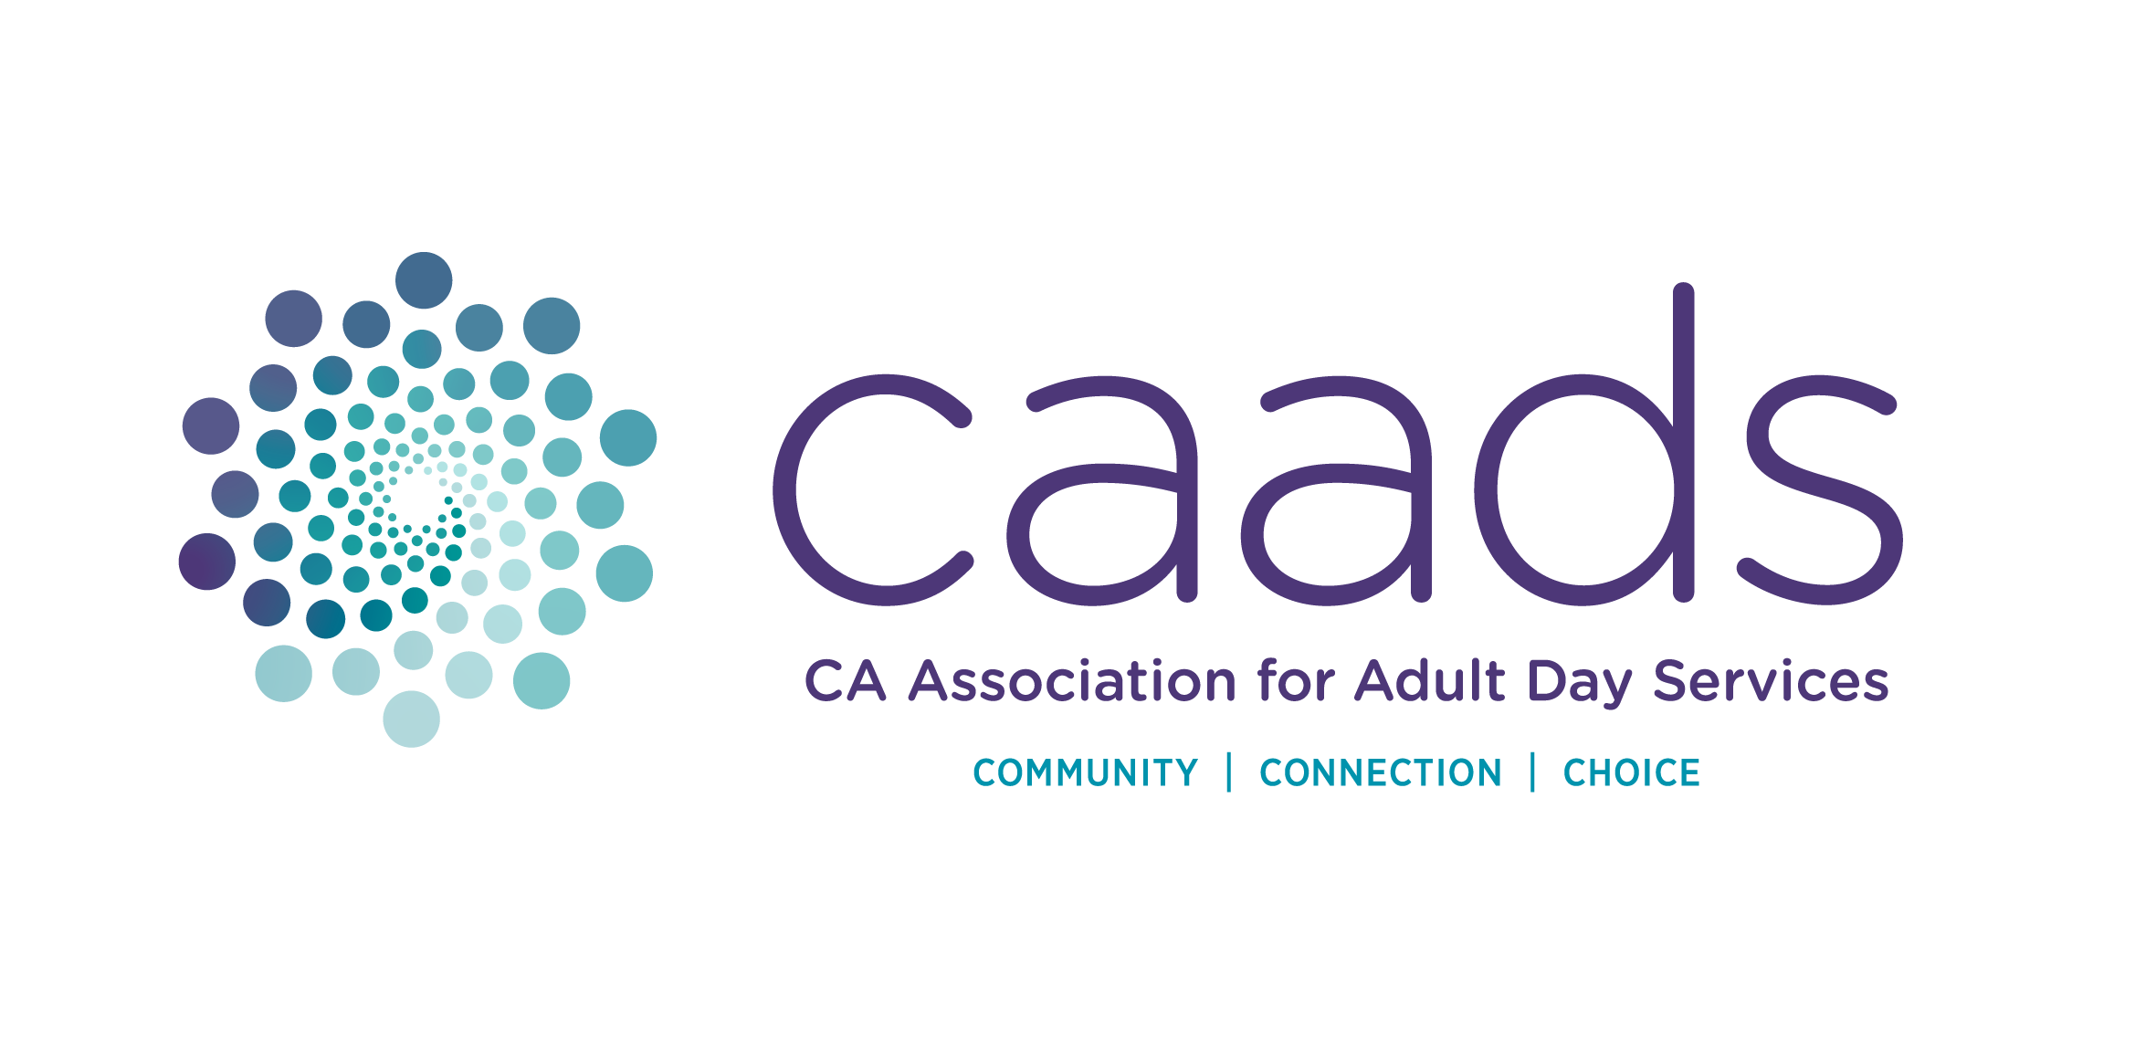 | ADVOCACY PLEDGE REMITTANCE  California Association for Adult Day Services  801 K Street, Suite 925 | Sacramento, CA 95814

Payment Amount: $_____________ Date: ________________

Please note, donations to the CAADS Advocacy Fund are not tax-deductible.

Organization (DBA):

- Check (Please enclose and make payable to: CAADS)

- Charge my card for the payment amount shown above:

❑ MasterCard (credit or debit card)  Visa (credit or debit card)  Discover (credit card)
Card Number: ___ ___ ___ ___ ___ ___ ___ ___ ___ ___ ___ ___ ___ ___ ___ ___

Card Expiration Date: _________________________ CVV Code: ___ ___ ___

Cardholder Name: ____________________________________________________________
(Please Print)

Cardholder Street Address: _____________________________________ ZIP: ____________
(Please Print)

Cardholder Email Address: ___________________________________________________
(Please Print, for receipt of payment)

Authorized Signature: _________________________________________________________

Cardholder Telephone Number: (________) _____________________

- Please Return Remittance Slip to:

CAADS
801 K Street, Suite 925
Sacramento, CA 95814-3518

T: (916) 552.7400 ~ F: (866) 725.3123 ~ E: accounting@caads.org

→ CAADS’ Returned Check Fee is $50.00 

→ Returned checks will be referred to the appropriate legal authorities.
→ Checks without a number or account holder imprint will not be accepted for payment.
→ If a charge card is declined, an alternative charge card may be submitted for verification.
A cashier’s check or money order will be required to honor the request.
→ It is your responsibility to ensure that sufficient funds are available for the transaction.

CAADS reserves the right to refuse service or membership privileges to any individual or company
that writes a check that is returned for insufficient funds or whose credit/debit card is declined.

