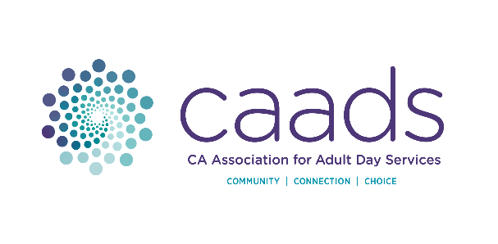 | ADVOCACY PLEDGE REMITTANCE  California Association for Adult Day Services  1107 9th Street, Suite 701 | Sacramento, CA 95814

Payment Amount: Date:
Please note, donations to CAADS Advocacy Fund are not tax deductible.

Organization (DBA):

- Check (Please enclose and make payable to CAADS)

- Charge my card for the payment amount shown above:

VISA (credit or debit card) MASTERCARD (credit or debit card) DISCOVER (credit card)

Card Number: - - -

Expiration (Month & Year): / C V V Code:

Name (as it appears on card):

Cardholder Street Address: Billing ZIP:

Cardholder Email:

Cardholder’s Signature:

Cardholder’s Telephone: ( )

- Please Return the Remittance Slip to:

CAADS
1107 9th Street, Suite 701
Sacramento, CA 95814-3610

T: (916) 552.7400 ~ F: (866) 725.3123 ~ E: accounting@caads.org

CAADS’ Returned Check Fee is $50.00

Returned checks will be referred to the appropriate legal authorities.
Checks without a number or account holder imprint will not be accepted for payment.
If a charge card is declined, an alternative charge card may be submitted for verification,
or a cashier’s check or money order will be required in order for the request to be honored.
It is your responsibility to assure that sufficient funds are available for the transaction.

CAADS reserves the right to refuse service or membership privileges to any individual or company
that writes a check that is returned for insufficient funds or whose credit/debit card is declined.

